**CS673 Software Engineering**

**Team 3 - StockPickers**

**Manual test Reports**

**Index :**

| **Case** | **Pass/Fail** |
| --- | --- |
| **01** | **Pass** |
| **02** | **Pass** |
| **03** | **Pass** |
| **04** | **Pass** |
|  |  |

## Test ID 01

|  | **Comment** | **Decision** |
| --- | --- | --- |
| Test ID | 01 |  |
| Tester: | Duy Nguyen |  |
| Test Description | Test the navigation of the app |  |
| Test Items | Navigation |  |
| Test Priority | Medium |  |
| Dependencies | requirements.txt |  |
| Input Data | None |  |
| Post Conditions | N/A |  |
| Expected Output | All links lead to the correct pages. |  |
| **Steps** | **Test Procedure** | **Decision** |
| 1 | Launch back end | Set up. |
| 2 | Launch front end | Set up. |
| 3 | Check home page | Pass |
| 4 | Click on dashboard | Pass |
| 5 | Click on About | Pass |
| ***Final Decision*** | | Pass |

## Test ID 02

|  | **Comment** | **Decision** |
| --- | --- | --- |
| Test ID | 02 |  |
| Tester: | Duy Nguyen |  |
| Test Description | Test if App displays graph |  |
| Test Items | Test if App displays graph |  |
| Test Priority | High |  |
| Dependencies | requirements.txt |  |
| Input Data | FSR selection/daily grain |  |
| Post Conditions |  |  |
| Expected Output | Stock data displayed in the form of a line graph |  |
| **Steps** | **Test Procedure** | **Decision** |
| 1 | Launch back end | Set up. |
| 2 | Launch front end | Set up. |
| 3 | Click on dashboard | Pass |
| 4 | Select FSR | Pass |
| 5 | Select Daily Grain | Pass |
| 6 | Select “”Get Selected Stock Data” | Pass |
| 7 | Graph Displayed? | Pass |
| 8 | Grain = Daily? | Pass |
| ***Final Decision*** | | Pass |

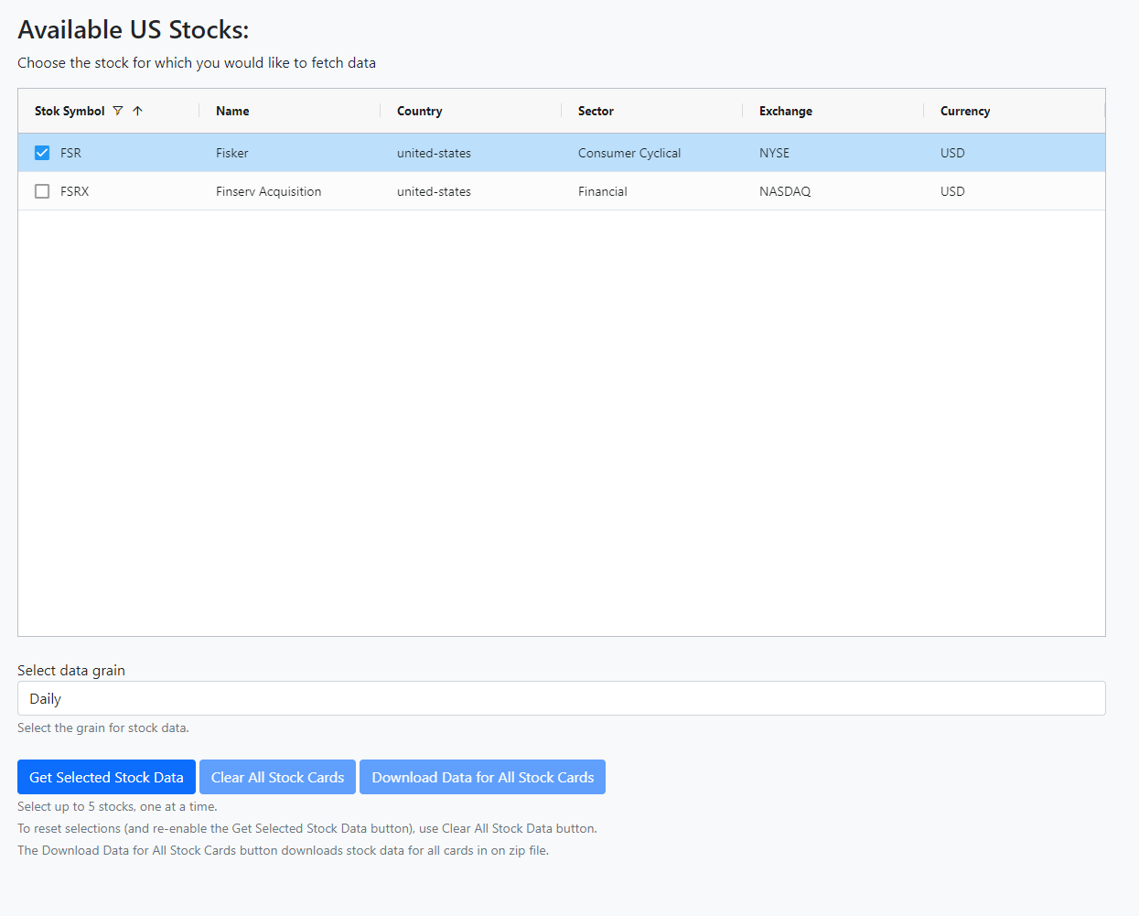

Test02-Fig1

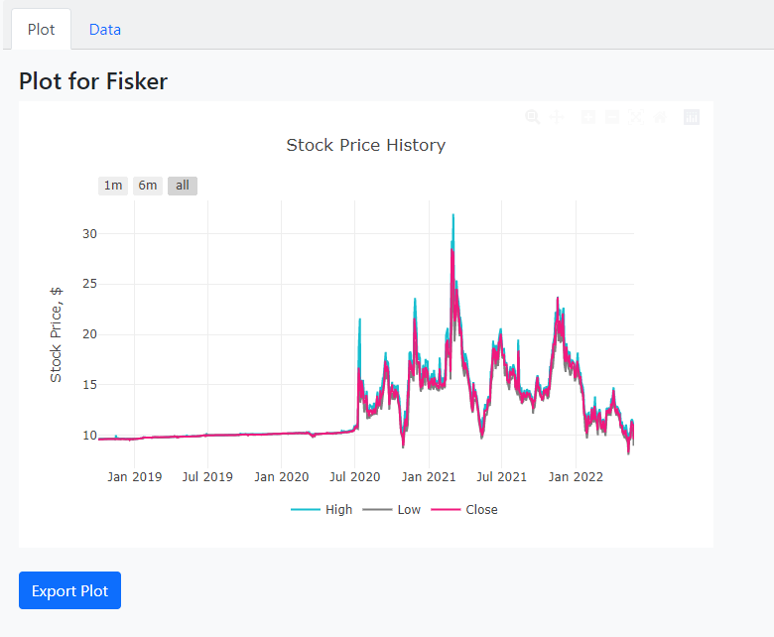

Test02-Fig2

## Test ID 03

|  | **Comment** | **Decision** |
| --- | --- | --- |
| Test ID | 03 |  |
| Tester: | Jing Tian |  |
| Test Description | Test if App displays all stocks correctly |  |
| Test Items | Test if App displays stocks correctly |  |
| Test Priority | High |  |
| Dependencies | requirements.txt |  |
| Input Data | N/A |  |
| Post Conditions | N/A |  |
| Expected Output | All stock will display in alphabetical order, and with correct information. |  |
| **Steps** | **Test Procedure** | **Decision** |
| 1 | Launch back end | Set up. |
| 2 | Launch front end | Set up. |
| 3 | Click on lauch app | Pass |
| 4 | Wait till every stocks loads | Pass |
| 5 | Check if there’s any stock missing or displayed incorrectly | Pass |
| ***Final Decision*** | | Pass |

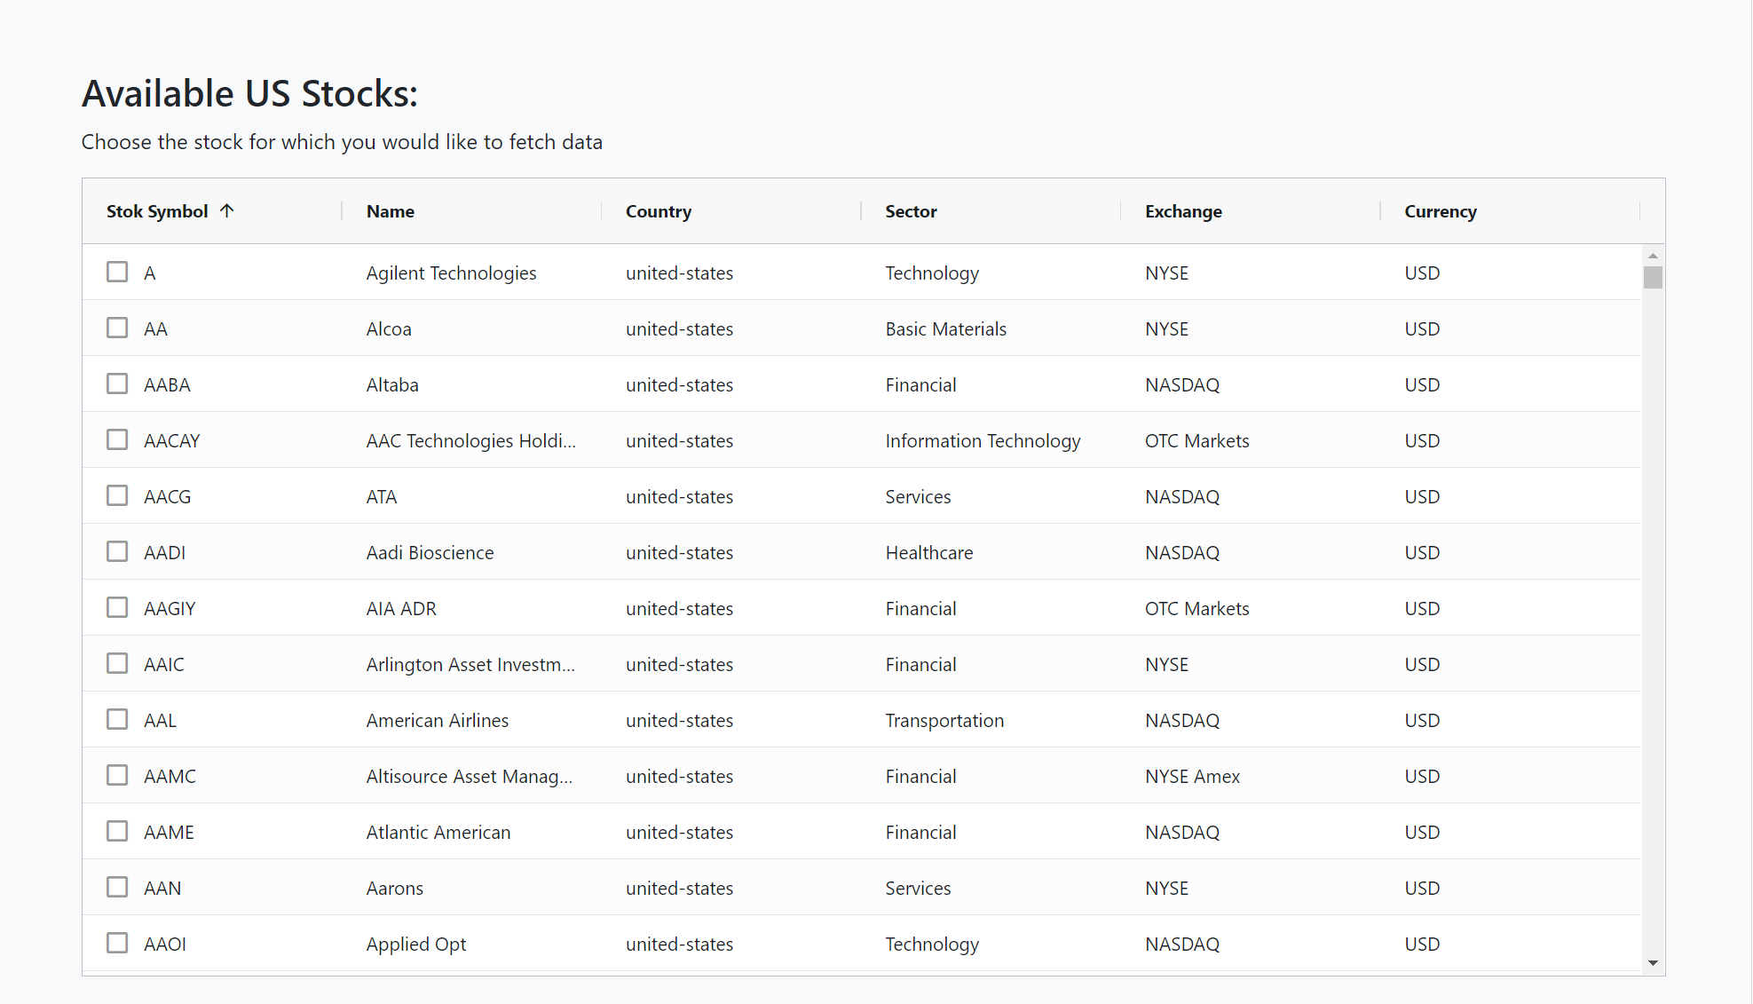

Test03-Fig3

## Test ID 04

|  | **Comment** | **Decision** |
| --- | --- | --- |
| Test ID | 04 |  |
| Tester: | Jing Tian |  |
| Test Description | Test if App fetched correct data |  |
| Test Items | Test if App fetched correct data |  |
| Test Priority | High |  |
| Dependencies | requirements.txt |  |
| Input Data | N/A |  |
| Post Conditions | N/A |  |
| Expected Output | The graph and fetched data should be consistant |  |
| **Steps** | **Test Procedure** | **Decision** |
| 1 | Launch back end | Set up. |
| 2 | Launch front end | Set up. |
| 3 | Click on lauch app | Pass |
| 4 | Choose one stock from stock list. | Pass |
| 5 | Display graph of that stock | Pass |
| 6 | Display data of that stock | Pass |
| 7 | Examine if graph and related data are consitant | Pass |
| ***Final Decision*** | | Pass |

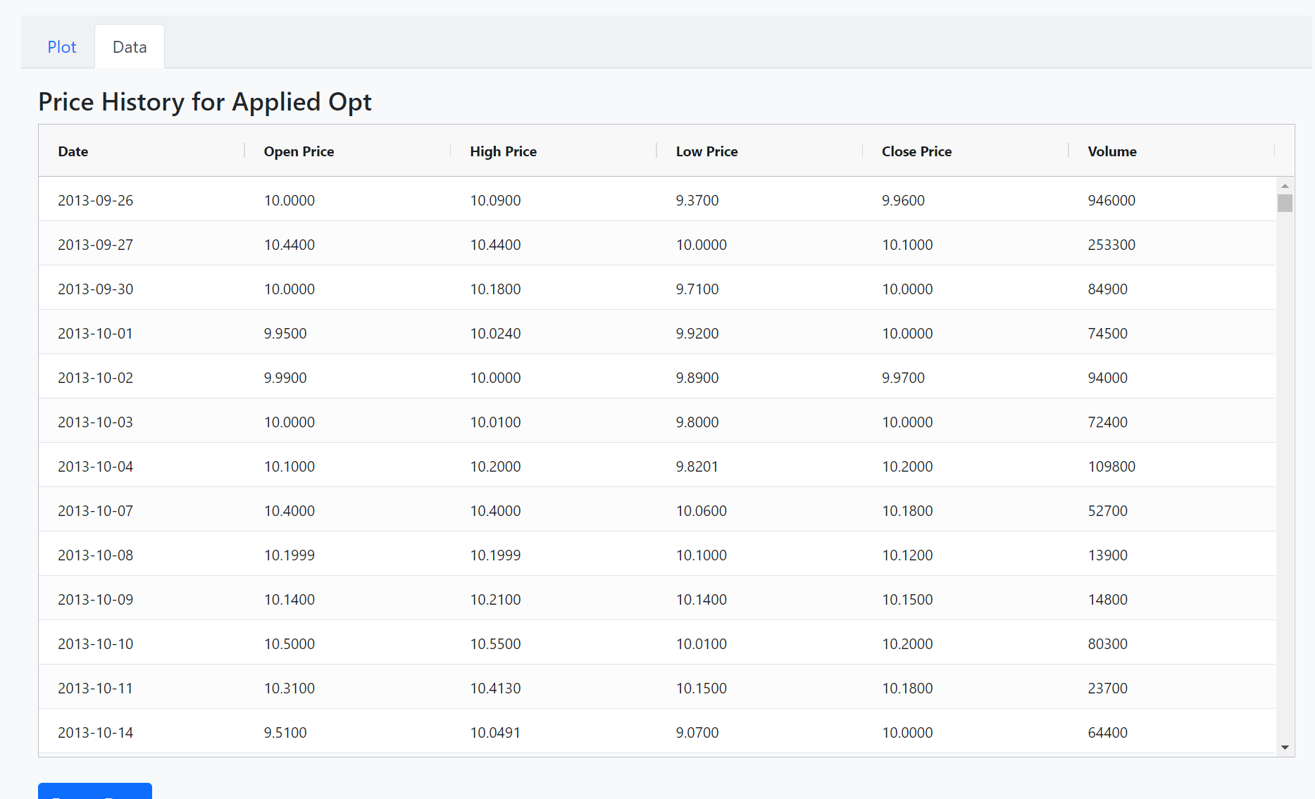

Test04-Fig4